Ideation Phase
Define the Problem Statements

Date | 9 July 2026
Team ID
Project Name | ShopEZ
Maximum Marks | 2 Marks

Customer Problem Statement
Before starting the development of ShopEZ, we identified the common challenges faced by different users. Understanding these problems helped us design features that address real user needs. The following problem statements represent the perspectives of potential users and guided us in defining the project requirements.
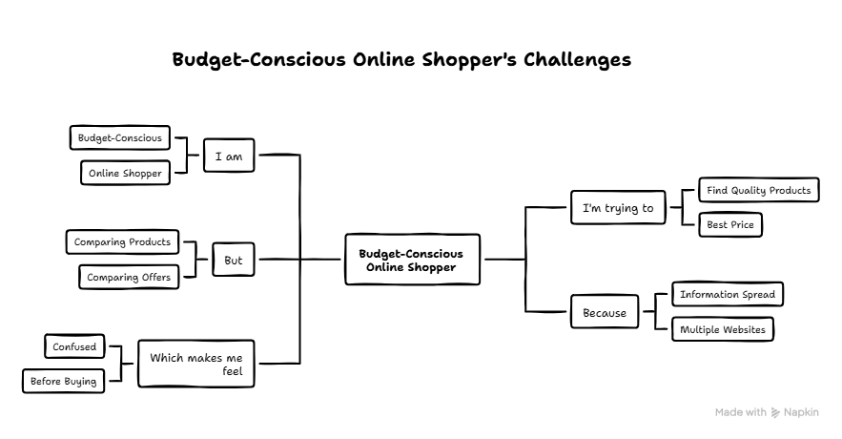


Conclusion
From the above problem statements, we observed that both customers and sellers face challenges with existing online shopping systems. Customers need a simple platform to discover products, compare options, and place orders easily, while sellers require an efficient way to manage products, inventory, and orders. These insights motivated us to develop ShopEZ, a centralized e-commerce platform that provides a seamless experience for customers, sellers, delivery managers, and administrators.

